PRACTICAL 3A: COMBINATIONAL CIRCUITSRonak Mehta (MHTRON001)

Plagiarism Declaration1. I know that plagiarism is wrong. Plagiarism is to use another’s work and pretend that it is  
one’s own.  
2. I have used the IEEE convention for citation and referencing. Each contribution to, and  
quotation in, this practical report from the work(s) of other people has been attributed and has  
been cited and referenced.  
3. This practical report (including circuit diagrams and code) is my own work.  
4. I have not allowed, and will not allow, anyone to copy my work with the intention of passing  
it off as their own work.  
5. I acknowledge that copying someone else’s code, schematics or report, or part of it, is wrong,  
and declare that this is my own work.

02-05-2018  
Signature Date

Solutions

a) Truth Table for 1-bit Half Adder

|  |  |  |  |
| --- | --- | --- | --- |
| **A** | **B** | **S** | **COUT** |
| 0 | 0 | 0 | 0 |
| 0 | 1 | 1 | 0 |
| 1 | 0 | 1 | 0 |
| 1 | 1 | 0 | 1 |

b) S = (A. $\overline{B}$) + ($\overline{A}$.B)

**S = A ⊕ B**

**COUT = A.B**

c) Truth Table for 1-bit Full Adder

|  |  |  |  |  |
| --- | --- | --- | --- | --- |
| **CIN** | **A** | **B** | **S** | **COUT** |
| 0 | 0 | 0 | 0 | 0 |
| 0 | 0 | 1 | 1 | 0 |
| 0 | 1 | 0 | 1 | 0 |
| 0 | 1 | 1 | 0 | 1 |
| 1 | 0 | 0 | 1 | 0 |
| 1 | 0 | 1 | 0 | 1 |
| 1 | 1 | 0 | 0 | 1 |
| 1 | 1 | 1 | 1 | 1 |

d)

S = ($\overline{A} . B. \overline{Cin}$) + (A . $\overline{B} . \overline{Cin}$) + ( $\overline{A}$. $\overline{B}$. Cin) + (A .B .Cin)

S = $\overline{Cin}\left(\left(\overline{A} . B\right)+\left(A . \overline{B}\right)\right)+Cin(\left(\overline{A} . \overline{B}\right)+(A.B))$

Let X = $\left(\overline{A} . B\right)+\left(A . \overline{B}\right)$ = A ⊕ B

Then, $\overline{X}= \left(\overline{A} . \overline{B}\right)+(A.B)$

Thus, S = $\overline{Cin}(X)+Cin(\overline{X})$ = CIN ⊕ X

**S = CIN ⊕ A ⊕ B**

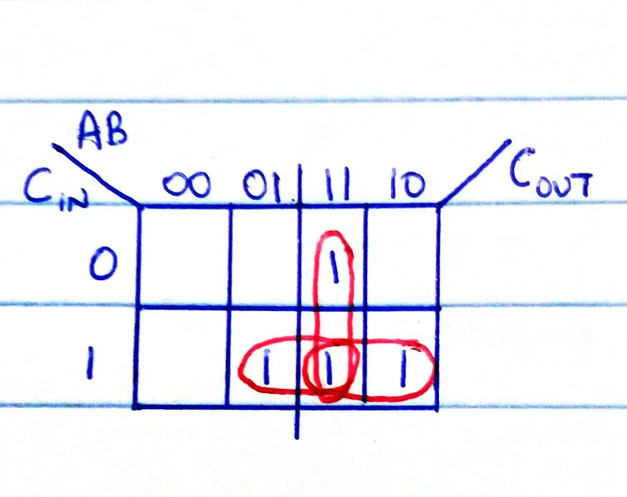

COUT = (CIN.B) + (CIN.A) + (A.B)

**COUT = CIN(A+B) + (A.B)**

e)

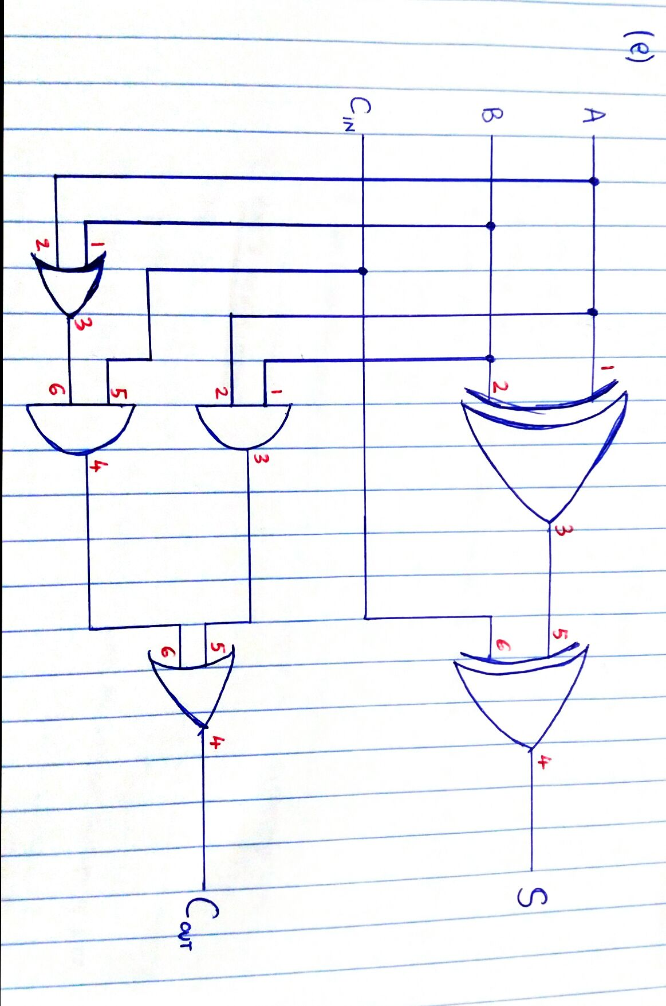

f) Truth Table for 1-bit Full Subtractor

|  |  |  |  |  |
| --- | --- | --- | --- | --- |
| **A** | **B** | **BIN** | **D** | **BOUT** |
| 0 | 0 | 0 | 0 | 0 |
| 0 | 0 | 1 | 1 | 1 |
| 0 | 1 | 0 | 1 | 1 |
| 0 | 1 | 1 | 0 | 1 |
| 1 | 0 | 0 | 1 | 0 |
| 1 | 0 | 1 | 0 | 0 |
| 1 | 1 | 0 | 0 | 0 |
| 1 | 1 | 1 | 1 | 1 |

g)

D = ($\overline{A} . \overline{B} . Bin$) + ($\overline{A} . B . \overline{Bin}$) + (A . $\overline{B} . \overline{Bin}$) + (A . B . Bin)

D = $\overline{A} (\left(\overline{B} . Bin\right)+(B . \overline{Bin}))$ + A(($\overline{B} . \overline{Bin}$)+(B . Bin))

**D = A ⊕ B ⊕ BIN**

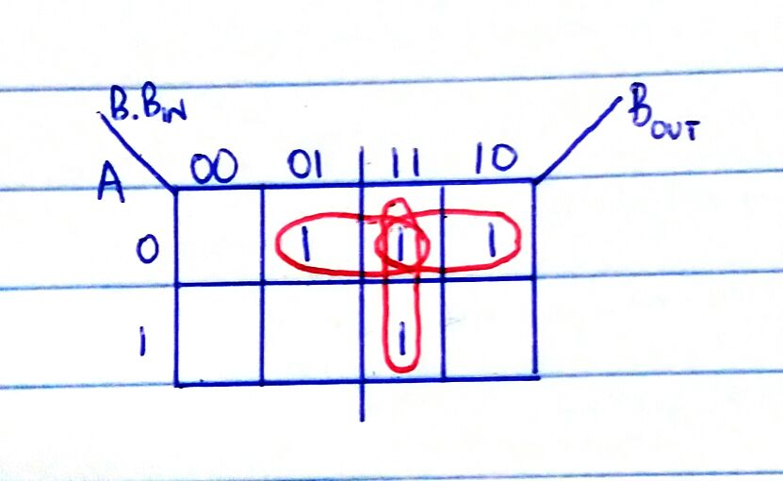

BOUT = (B. BIN) + ( BIN) + ( . B)

**BOUT = BIN ( + B) + ( $\overline{A}$. B)**

h)

A full Adder can be used as a Full Subtractor by connecting a NOT gate on one of the inputs and connecting the CIN input to a HIGH. By connecting the NOT gate, we are converting the input to its 2’s compliment. We can also do this by adding an XOR gate to one of the inputs.

i)

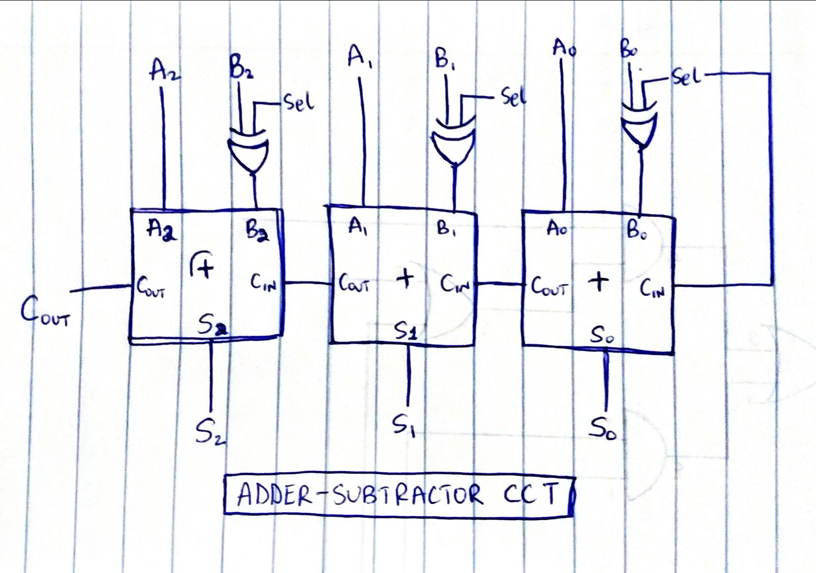

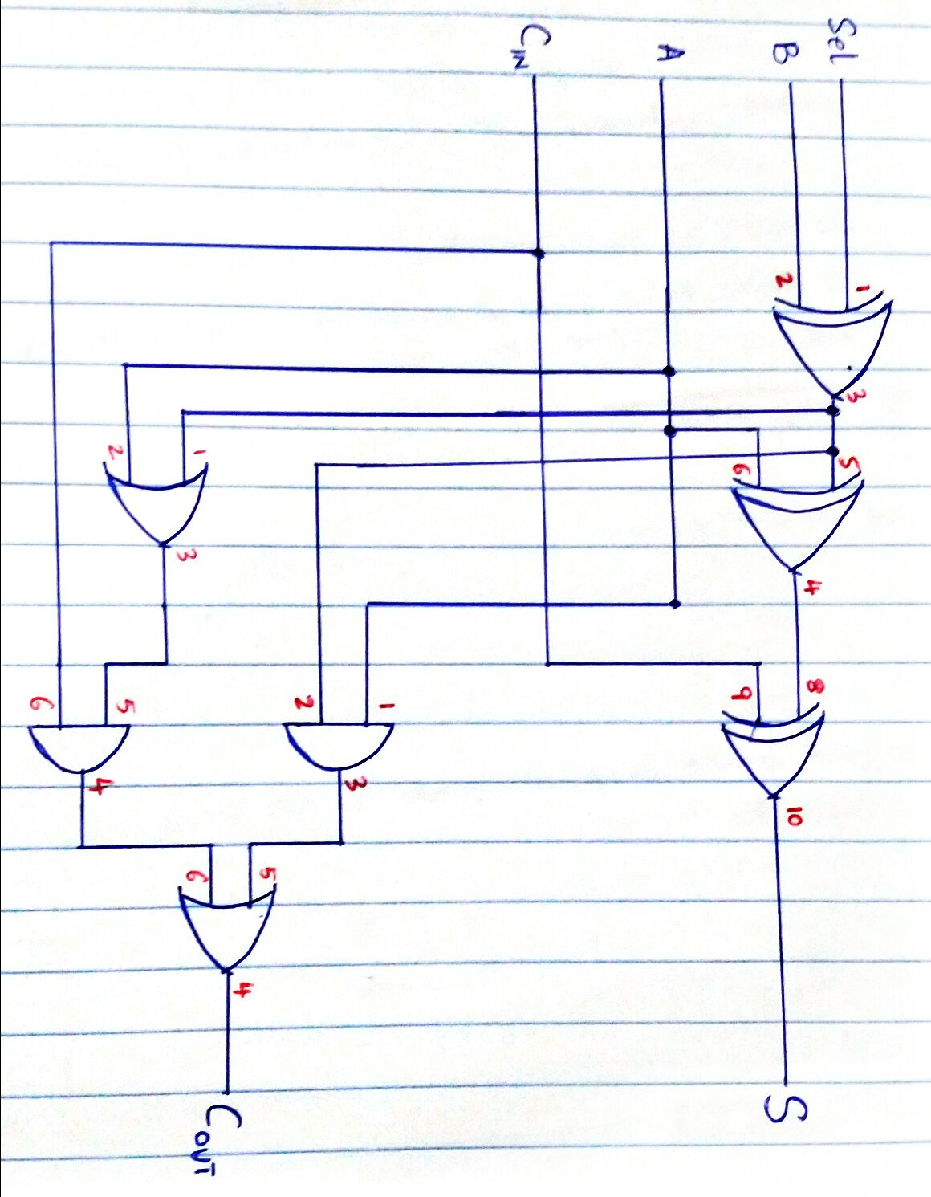

k)

|  |  |  |  |  |  |  |
| --- | --- | --- | --- | --- | --- | --- |
| **CIN** | **A** | **B** | **Sel** | **S** | **COUT** | **VERIFIED the S variable** |
| 0 | 0 | 0 | 0 | 0 | 0 | 0 |
| 0 | 0 | 0 | 1 | 1 | 1 | 1 |
| 0 | 0 | 1 | 0 | 1 | 0 | 1 |
| 0 | 0 | 1 | 1 | 0 | 0 | 0 |
| 0 | 1 | 0 | 0 | 1 | 0 | 1 |
| 0 | 1 | 0 | 1 | 0 | 1 | 0 |
| 0 | 1 | 1 | 0 | 0 | 1 | 0 |
| 0 | 1 | 1 | 1 | 1 | 0 | 1 |
| 1 | 0 | 0 | 0 | 1 | 0 | 1 |
| 1 | 0 | 0 | 1 | 0 | 1 | 0 |
| 1 | 0 | 1 | 0 | 0 | 1 | 0 |
| 1 | 0 | 1 | 1 | 1 | 0 | 1 |
| 1 | 1 | 0 | 0 | 0 | 1 | 0 |
| 1 | 1 | 0 | 1 | 1 | 1 | 1 |
| 1 | 1 | 1 | 0 | 1 | 1 | 1 |
| 1 | 1 | 1 | 1 | 0 | 1 | 0 |